Write a program for Travelling Salesman Probelm using python code

Aim :To solve the Travelling Salesman Problem (TSP) using Python.
Procedure:
Define the distance matrix between cities.
Generate all possible routes.
Calculate the total distance for each route.
Select the route with the minimum distance.
Display the shortest route and its cost.

PYTHON CODE:
from itertools import permutations
cities = ['A', 'B', 'C', 'D']
distance = [
[0, 10, 15, 20],
[10, 0, 35, 25],
[15, 35, 0, 30],
[20, 25, 30, 0]
]
start = 0
min_cost = float('inf')
best_route = []
for route in permutations(range(1, len(cities))):
cost = 0
current = start
for city in route:
cost += distance[current][city]
current = city
cost += distance[current][start]
if cost < min_cost:
min_cost = cost
best_route = route
print("Shortest Route:")
print(cities[start], end=" -> ")
for city in best_route:
print(cities[city], end=" -> ")
print(cities[start])
print("Minimum Cost =", min_cost)
OUTPUT:
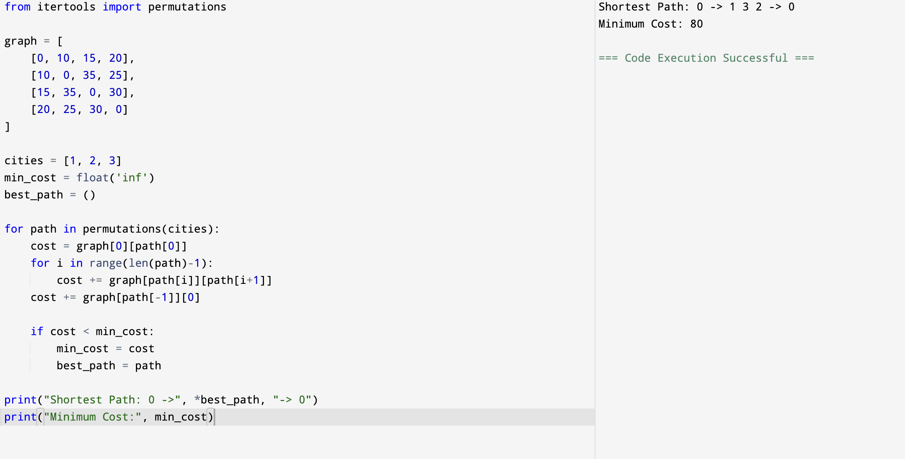
FLOWCHART:

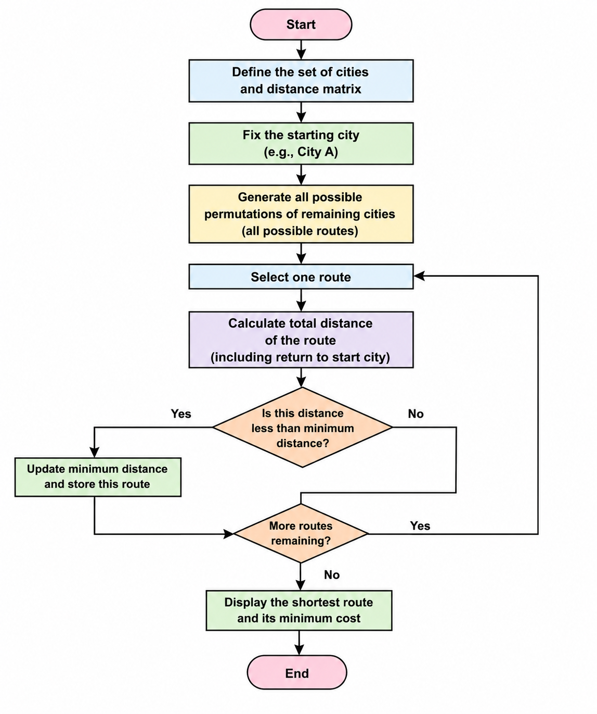

Result: Hence, Travelling Salesman problem has solved

